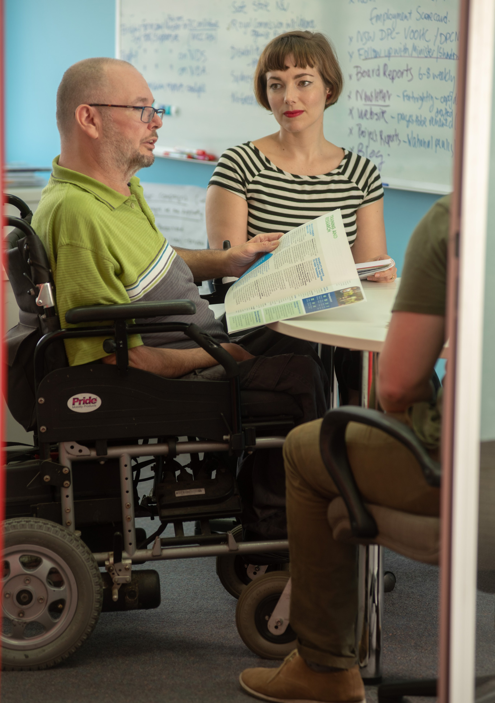

WHAT DO I SAY?
A guide to language about disability

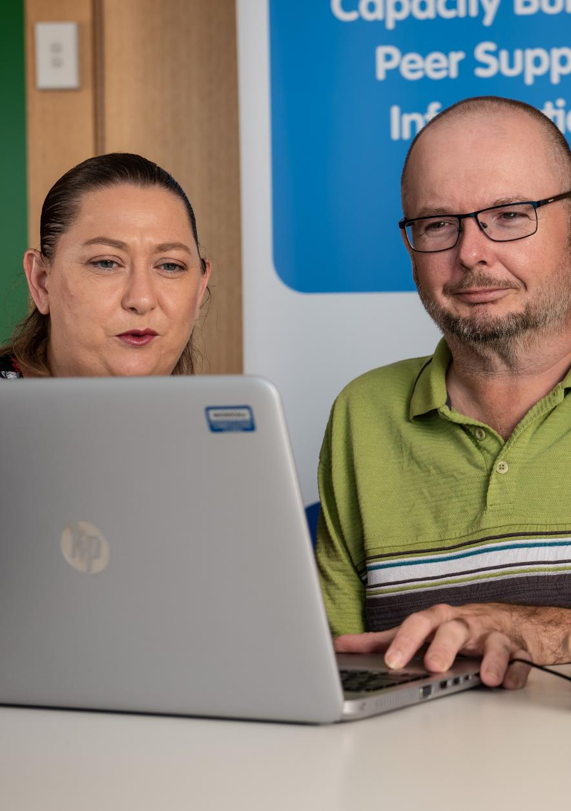

2

CONTENTS

What do I say?
Introduction 1 About People with Disability Australia 3 What’s the social model of disability? 5 Identity first vs person first language 7 What is ableist language and what’s the impact of using it? 10

Media
Reporting on disability 12 Whose story are you telling? 13 Who is telling the story? 15

Terminology
List of words and recommended alternatives 17
Language to avoid 23

INTRODUCTION

This guide has been written by people with disability to assist the Australian general public and media outlets in talking about and reporting on disability.
The choices people make about language have an impact on the way people with disability feel and are perceived in
society. It is important that there is awareness of the meaning behind the words that are used when talking to, referring to, or working with people with disability. Disrespectful language can make people with disability feel hurt and excluded, and be a barrier to full participation in society.
There are over 4 million Australians with disability who watch television, read online stories, listen to the radio or podcasts and share news on social media. Yet, discussions and media stories about us don’t reflect the diversity or reality of our lives.
People with disability are often described in ways that are disempowering, discriminatory, degrading and offensive. Negative words such as ‘victim’ or ‘sufferer’ reinforce stereotypes that people with disability are unhappy about our lives, wish we were ‘normal’, and should be viewed as objects of pity.
These harmful stereotypes are simply not true. People with disability are people first – people who have families, who work, and who participate in our communities. People with disability want our lives to be respected and affirmed. In addition, many people with disability are proud of being disabled, and want that identity respected.

Content note: This guide contains ableist
and offensive language.

1

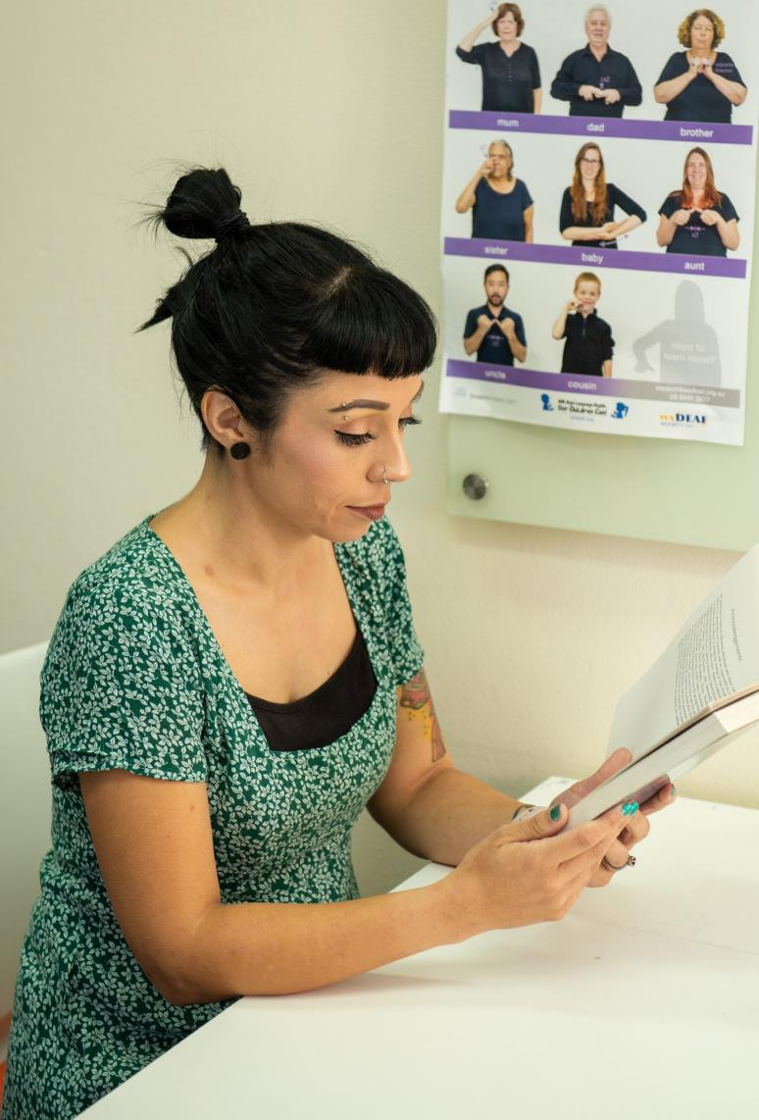



(

2

ABOUT PEOPLE WITH DISABILITY AUSTRALIA

People with Disability Australia (PWDA) is a national disability rights, advocacy and representative organisation that is made up of, led and governed by people with disability. We represent all people with disability
across Australia.
We have a vision of a socially just, accessible and inclusive community, in which the human rights, belonging, contribution, potential and diversity of all people with disability are recognised, respected and celebrated with pride.
Our members, people with disability and organisations made up of people with disability, are actively involved in PWDA, electing a Board of people with disability every year. Many of our staff are also people with disability.
Founded in 1981, the International Year of Disabled Persons, People with Disability Australia provides people with disability with a voice of our own. We have a cross-disability focus representing the interests of people with all kinds of disability. We are a non-profit, non-government organisation.

3

We work across Australia. PWDA also represents people with disability at the United Nations, particularly in relation to the Convention on the Rights of Persons with Disabilities. PWDA is designated Disabled People’s Organisation.
PWDA is a member of Disabled People’s Organisations Australia (DPO Australia), along with First Peoples Disability Network, National Ethnic Disability Alliance and Women with Disabilities Australia.
DPO Australia promotes and advances the human rights and freedoms of all people with disability in Australia by working together on areas of shared interests, strategic priorities and opportunities. Our work is grounded in
a human rights framework that recognises the United Nations human rights conventions and related mechanisms as fundamental tools for advancing
the rights of people with disability.

4

WHAT’S THE SOCIAL MODEL OF DISABILITY?

People with Disability Australia uses the social model of
disability to talk about disability, and people with disability.
In this model, disability is the result of the interaction between people with impairments and an environment filled with physical, attitudinal, communication and social barriers. The social model has the implication that the physical, attitudinal, communication and social environment must change to enable people living with impairments to participate in society on an equal basis with others.
The social model contrasts with the medical model of disability, where disability is seen to be a problem of the individual. From the medical model, a person with disability is in need of being fixed or cured. From this point of view, disability is a tragedy and people with disability are to be pitied. The medical model of disability is all about what a person cannot do and cannot be.
The social model does not deny the reality of impairment nor its impact on the individual. However, it does challenge the physical, attitudinal, communication and social environment to accommodate those impairments.
The social model seeks to change society in order to accommodate people living with impairment; it does not seek to change persons with impairment to accommodate society. It supports the view that people with disability have a right to be fully participating citizens on an equal basis with others.

5

People with disability want our lives to
be respected and affirmed. In addition, many people with disability are proud of being disabled, and want that identity respected.
6

IDENTITY FIRST VS PERSON FIRST LANGUAGE

Both person first and identity first language are used in Australia to refer to people with disability, or disabled people. People with disability often have very strong preferences for either identity first, or person first language. Non-disabled people need to be led by, respect and affirm the each individual person with disability’s choice of language they use about themselves.
PWDA, other Disabled People’s Organisations, governments, government and non-government institutions predominantly use ‘person-first’ language when referring
to people with disability. Generally, this is on the basis that a person’s disability should not be unnecessarily focused on. The dehumanisation of people with disability is still a huge problem and has been for a long period of history, so we choose to preface our language with a reminder of personhood.
Phrases like ‘the disabled’ or calling someone ‘a wheelchair’ reflect the assumption that people are reduced to just their disability (even so far as to refer to them as their mobility aid). Defining people by their disability is often used as an excuse to ignore our humanity – to put us in a separate and lesser category so that non-disabled people don’t have to think about the wants, needs, rights or feelings of people with disability.

7

Violence against people with disability is often justified by talking about us as if we have a reduced level of consciousness or are not as much of a person as non- disabled people. Referring to someone as if they are
nothing other than their disability – such as calling them ‘the wheelchair’ – is not ok.
Many people with disability also embrace ‘identity-first’ language, which positions disability as an identity category. This language is known as ‘identity-first’ because the identifying word comes first in the sentence and highlights the person’s embrace of their identity. For example, “I am a disabled person, like I am an Australian person or a bisexual person.”
For disabled people, their disability is an aspect of their person that they can’t control, but that they embrace as part of who they are. As an identity category, disability does not merely describe an individual body or mind, but membership within a wider cultural group.
Some specific disability communities, such as Autistic and Deaf communities, will primarily use identity-first language, and may prefer not to refer to themselves as disabled at all.
Affirming disability as an identity positions the individual to personally identify as disabled, by their own choice, rather than being told they are disabled by an external (usually non-disabled) ‘authority’.

8

PWDA does not support the use of euphemisms, such as ‘handicapable’ or ‘differently-abled’ or ‘special needs’ or ‘living with disability’, to refer to people with disability.
The term ‘Disabled People’s Organisation’ or ‘DPO’ is used to describe non-government organisations that are governed, led and constituted by people with disability.
‘DPO’ became the internationally accepted term at the time of the International Year of Disabled Persons in 1981, when people with disability all over the world began to organise ourselves into our own organisations.1
DPOs collectively form a disability rights movement
that places people with disability at the centre of decision-making in all aspects of our lives. This is known internationally through the motto, “Nothing About Us, Without Us”.
We have named our alliance, Disabled People’s Organisations Australia (DPO Australia) to make it clear that we are made up of DPOs that are part of the
international disability rights movement, and that our work is underpinned by the CRPD and a human rights framework.

9

WHAT IS ABLEIST LANGUAGE AND WHAT’S THE IMPACT OF USING IT?

Ableist language is language that is offensive to people with disability. It can also refer to language that is derogatory, abusive or negative about disability. Ableism is the systemic exclusion and oppression of people with disability, often expressed and reinforced through language.
While some words are inoffensive in certain contexts (for example, it is appropriate to call some window coverings ‘blinds’, but the word ‘blind’ would become derogatory if you were saying ‘the Prime Minister was blindly following advice’), some words are offensive in any context and should always be avoided.
Many derogatory words for people with disability – like ‘retard’ ‘moron’ and ‘idiot’ – began as medical definitions used to categorise people with disability as lesser humans. These terms, once prominent in medical textbooks and used in scientific journals, were used a time of widespread eugenics of people with disability, such as forced sterilisation and institutionalisation. A term’s clinical origins do not mean it is OK to use. These terms are strong slurs against people with disability, are very offensive and should never be used.
A word’s meaning cannot be erased with good intentions.
People may not intend to be hurtful when they unknowingly use an ableist term, but it will hurt people anyway. Ableist language harms people with disability, and using these terms shows that people with disability aren’t valued. Every effort should be taken to avoid the use of ableist language and if it is used in error, it should be corrected and an apology made.
10

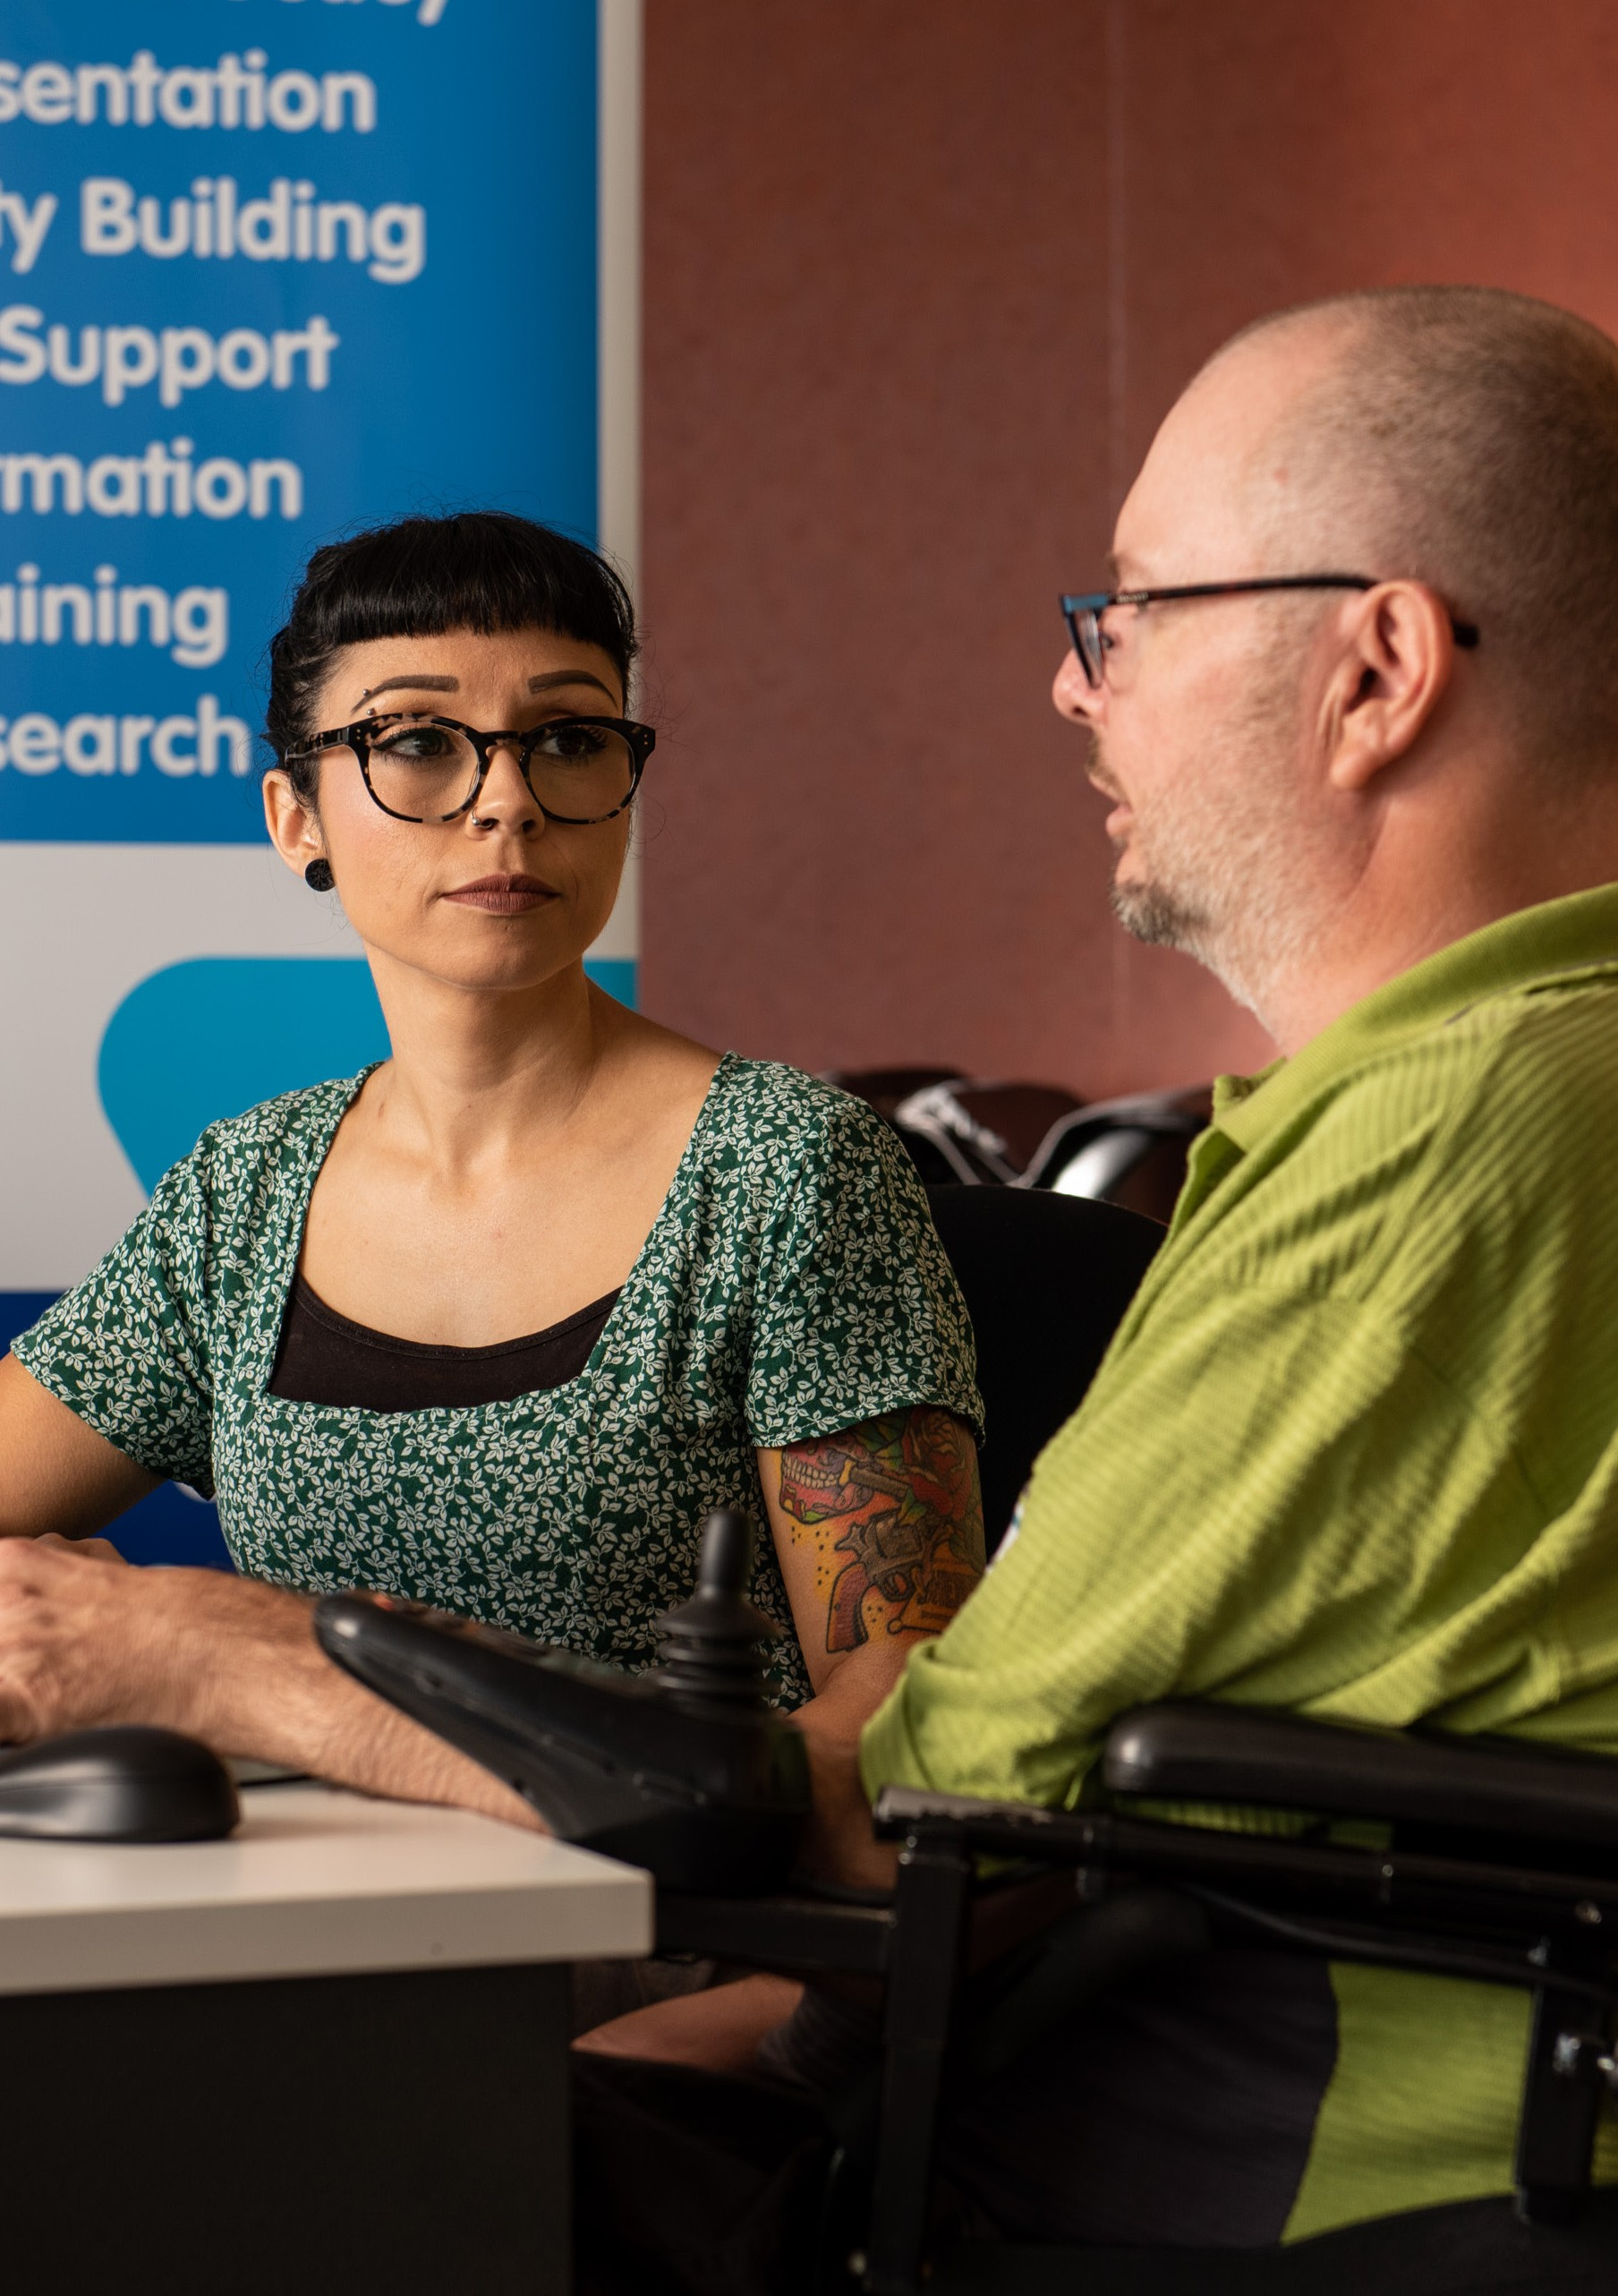

11

REPORTING ON DISABILITY

Disability is a common fact of life and part of human diversity, it is not something to be dramaticised or sensationalised. Avoid stories where, if the main subject’s disability was not mentioned, there would be no hook to the story.
If a person has achieved something newsworthy, like winning a national portrait prize, then that is wonderful and needs
to be rightly celebrated. But if that person has disability, the report should not make it seem as if their disability makes their achievement unbelievable, poignant, or more interesting. It isn’t a surprise when people with disability achieve things.
If the fact that the person has disability was removed, would the story be about a mundane, everyday activity? Generally, if a person with disability is doing something that is ordinary for non-disabled people, then it’s probably ordinary for us as well.
Australian comedian and disability activist Stella Young often spoke against what she termed ‘inspiration porn’ (another term used
is ‘inspiration objectification’). This is the kind of emotive media portrayal of a person with disability where the simple fact of their life is meant to inspire others to be grateful for their own non-disabled lives. These stories objectify people with disability as tragic figures of pity for the entertainment of everyone else. These are exploitative and hurtful portrayals of disability.
Avoid referring to a person ‘inside’ the disability (e.g. ‘the man inside the paralysed body’) or ‘beyond’ their disability (e.g. ‘she transcended her disability’). Consider that our bodies and/or minds cannot be separated from who we are. There is not a non-disabled person hidden inside us. If you are writing about people as if their selves can exist separately from their bodies or minds, that’s not reporting – that’s futurism and best left to speculative fiction.
Ask each person with disability how they like to be described, and when in doubt, refer to the person with disability by their name.

12

WHOSE STORY ARE YOU TELLING?

When reporting on disability, be sure to centre people with disability. All too often, people with disability are spoken for or over by family members, carers, service providers, advocates, academics or any non-disabled person who claim authority and expertise over our lives. People with disability have historically been blocked from having a say in our own lives. When doing a feature on a person with disability, the only authority on that person’s life is that person.
Be aware of whose story you are telling. Is it the ‘brave’ tale of the mother who loves her adult child with disability, while the person with disability is only mentioned for how their existence affects everyone else? Are you focussing on how ‘inspiring’ it is that the non-disabled people treat their friend with disability like a friend?
Too often, stories about people with disability are actually stories about the people without disability around them. Caring for, supporting, befriending, parenting or working with a person with disability should not be presented as some kind of incredible or burdensome act, because this implies that the most credible outcome would have been for the person with disability to be abandoned and neglected by all.
Remember that people with disability are people with human rights the same as everyone else, and having our human rights fulfilled should be expected.
13

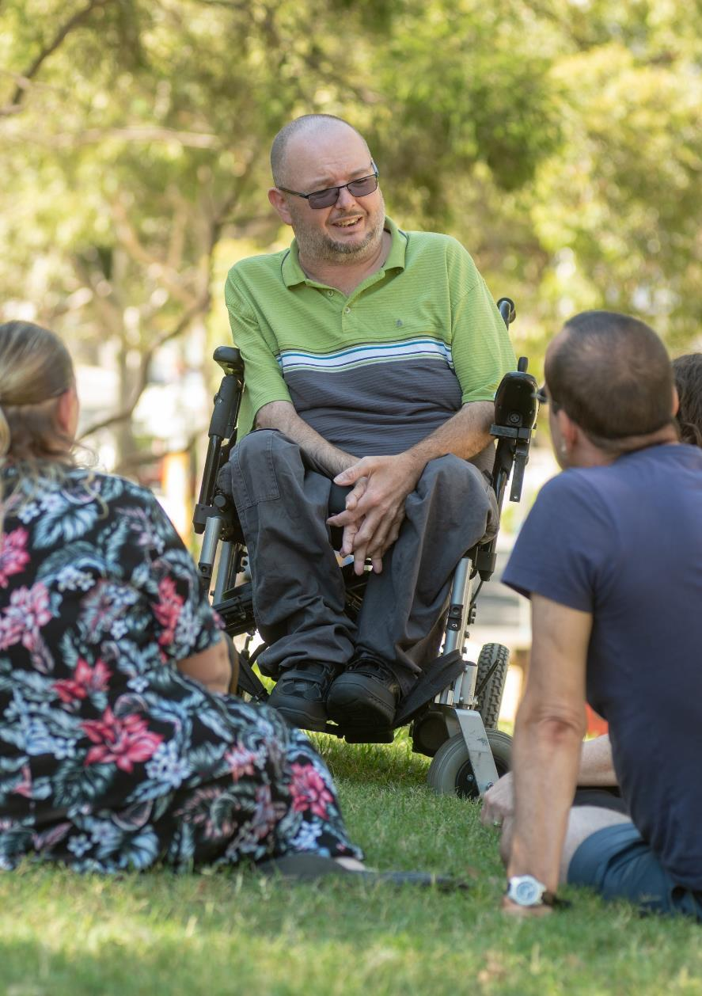

14

WHO IS TELLING THE STORY?

When reporting on an issue that specifically affects people with disability, it is best practice to employ a reporter with disability to cover it (especially for an opinion piece). You are more likely to get accurate reporting on disability from someone who actually has disability. If you don’t have at least one reporter with disability on staff, and don’t know of any freelance journalists with disability you could employ, it is time to seek them out.
People with disability are not one homogenous group; an autistic person may have a very different experience of disability to a person with a below-the-knee amputation. There is not one spokesperson for all people with disability.
Hire people with disability to report on non-disability-related issues. People with disability are people first, and we have perspectives on more than just disability.
People with disability make up close to 20% of Australia’s population, which means that approximately one in five people in this country can speak with authority about disability.
There are organisations that are designated disabled people’s organisations (DPOs) – they are , run by, led by and for people with disability. These organisations are different from, and will have a different perspective, than organisations who represent disability service providers, carers, families or commercial business.

15

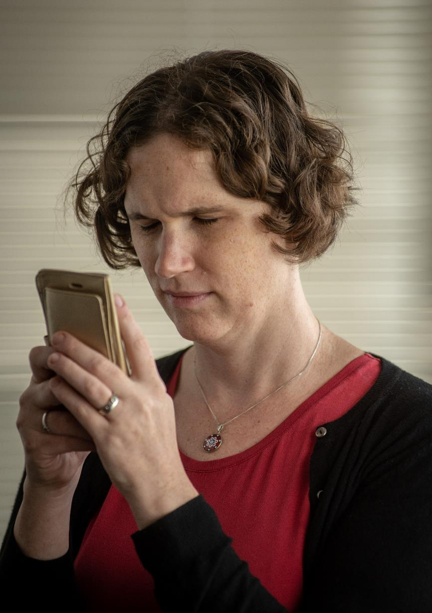

16

LIST OF WORDS AND RECOMMENDED ALTERNATIVES

 | Terms to avoid | Recommended alternatives
When referring to people with disability in general | afflicted by  crippled by  diffability | people with disability (women with disability, children with disability, etc)  has disability
 | differently abled | lives with disability
 | handicap(ped)  handicapable | has a chronic health condition
 | person with a disability | lives with a chronic health  condition
 | people with disabilities
 | specially abled
 | special needs
 | suffers from
 | the disabled
 | victim of
 | with different abilities
When referring to someone who uses a wheelchair | confined to a  wheelchair wheelchair-bound | wheelchair user  person who uses a wheelchair
17

When referring to a person whose legs and/ or lower body are paralysed | paraplegic | person with paraplegia
When referring to a person who has four limbs paralysed | quadriplegic | person with quadriplegia
When referring to a person of short stature or with a form of dwarfism | dwarf  midget | person of short stature
When referring to someone with an intellectual disability | intellectually challenged mental defective mentally retarded mentally disabled simple  special moron retard retarded imbecile cretin | person with cognitive  disability  person with intellectual disability

18

When referring to someone who has Down syndrome | downy  mongol(oid) | person with Down syndrome
When referring to someone who has learning disability | slow  slow learner retarded special needs | person with learning  disability
When referring to a person diagnosed with Attention Deficit Hyperactivity  Disorder (ADHD) | hyper  hyperactive | person with ADHD
When referring to a person with a brain injury | brain-damaged  brain-impaired | person with a brain injury
When referring to someone who has autism | aspy/aspie  autistic*  high-functioning  autism  profoundly autistic | autistic person* person with autism  person on the autism spectrum  neuroatypical  neurodivergent

19

When referring to someone with psychosocial disability | crazy insane/insanity mad  manic maniac mental mental case  mental defective mentally unstable psycho(tic) psychopath(ic) | person with psychosocial disability  person with a mental health condition  person with (insert the name of their condition if you know it and have their consent  to disclose it) (e.g. person with depression, person with bipolar disorder, etc)
When referring to someone with sensory disability | blind as a bat deaf and dumb mute | b/Blind (if they identify  that way)  d/Deaf (if they identify  that way)  hard of hearing (sometimes stylised as HoH)  person with a hearing  impairment  person with a visual  impairment  person with vision  impairment

20

When referring to someone who does not have disability | able-bodied** abled** healthy hearing normal  of sound body  sighted  well | person without disability non-disabled person
When referring to someone who does  not have intellectual, psychosocial or cognitive disability | normal  of sound mind | neurotypical
* Some people with autism identify as autistic people, or do not find the term ‘autistic’ offensive, because they consider autism an identity beyond the medical diagnosis.
** Some people with disability who use identity-first language will use ‘abled’ to describe non- disabled people, and ‘able-bodied’ to describe people without physical or mobility-related disability.

21

Remember that people with disability are people with human rights the same as everyone else, and having our human rights fulfilled should be expected.
22

LANGUAGE TO AVOID

The following are derogatory terms for people with intellectual or cognitive disability, no matter the context in which they are said. Usage should always be avoided. The terms are listed here in the aim of education on their origins and why they must be avoided andPWDA does not condone their use.
- brainless • cretin
- derp(y) • dim(-witted)
- dumb • idiot(ic)
- imbecile/imbecilic • feeble-minded
- few short of a • mental(ly) defective
- mongol(oid) • moron(ic)
- mong • nong
- retard(ed) • simple-minded
- simpleton • stupid
- slow-witted (also fuckwit, witless)
The following are derogatory terms for people with psychosocial disability, no matter the context in which they are said. Usage should always be avoided. The terms are listed here in the aim of education on their origins and why they must be avoided, but PWDA does not condone their use.
- crazy • daft
- insane/insanity • loony
- lunatic • mad(ness)
- madhouse/madman • maniac
- mental case • nuts
- psycho(tic) • psychopath(ic)
- sped (from ‘special education’) • whacko

23

The following are derogatory terms for people with physical or mobility-related disability, no matter the context in which they are said. Usage should always be avoided. The terms are listed here in the aim of education on their origins and why they must be avoided and PWDA does not condone their use.
- cripple • crip
- crippled by • handicapped
- gimp(y) • invalid
- lame • spastic/spazz
It is important to note that some derogatory terms have been reclaimed by some people with disability, but that does not mean those terms are appropriate for non- disabled people to use. For some people with disability, proudly identifying as ‘a crip’ or ‘mad’ is a way of surviving in a world that is still slinging those slurs at us. It may feel empowering for some people with disability to take back a violent word, but others will find the word still unbearably painful. Avoid or approach these words with caution because they have a violent history (and present).

24


‘What do I say? A guide to language about disability’
© People With Disability Australia 2019

